**Assessment 5**

Class-5

E-mail address:

Write your name:

**1.** Items are accessed by their position in a dictionary and all the keys in a dictionary must be of the same type. (2 points)

* True
* False

**2.** What will be the output of this code? (3 points)

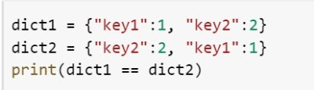

* True
* False

**3.** What will be the output of this code? (5 points)

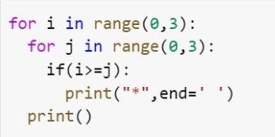

* Option 1

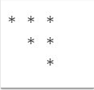

* Option 2

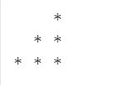

* Option 3

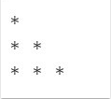

* Option 4

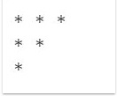

**4.** What will be the output of this code? (2 points)

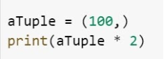

* TypeError
* (100, 100)
* (200)
* None of them

**5.** Select true statements regarding the Python tuple. (3 points)

* We can remove the item from tuple but we cannot update items of the tuple.
* We cannot remove the items from the tuple.
* We cannot update items of the tuple.
* We cannot delete the tuple.